HCI

Final exam notes

**Intro** **1**

**Data gathering** **2**

**Focus groups and contextual inquiry** **3**

**Think aloud and heuristic evaluation** **4**

**Ethics** **6**

**Personas and GOMS** **7**

**Interface conceptualization (start of design)** **7**

**Human capabilities / Gestalt principles** **9**

**Storyboards and Patterns** **9**

**News** **10**

# Intro

Design process:

* Planning, scoping, definition: What do we want to do?
* Exploration, synthesis, design: Would it work? Would it solve the problem?
* Concept generation: Create a prototype and try it out.
* Evaluation, refinement, production: Build it, test it, fix it.
* Launch and monitor: See if it works in the real world and perform ongoing review

Learning order:

* Design requirements: What do we want to do?
* Evaluation: Does the design work?
* Concept generation: Prototyping, matching needs.
* Interface design: Common approaches.
* Evaluation, with data: Quantitative.

Questionnaires (used in requirements or evaluation)

* Pros: large sample size, easy to analyze responses to close-ended questions (although hard to write), can determine how prevalent an issue is
* Cons: can only gather data you know about, careful planning required, open-ended questions take more analysis (but easier to write)
* Can test: attitudes, behaviors, conceptualizations, expectations, capabilities
* Likert scales popular: use response anchors (e.g., 1 = not at all important, 2 = low importance, 3 = slightly important, 4 = neutral, …, 7 = extremely important)

# Data gathering

Will cover:

* Five key issues of data gathering, data recording, interviews, questionnaires, observation, and choosing/combining techniques

Five key issues:

* Setting goals: Decide how to analyze data once collected.
* Identifying participants
* Relationship with participants: Clear and professional. Informed consent when appropriate.
* Triangulation: Look at data from more than one perspective.
* Pilot studies: Small trial of main study.

Interviews:

* Structuredness:
  + Unstructured: rich but not replicable
  + Structured: replicable but may lack richness
  + Semi-structured: guided by script but can be explored in more depth; may be good compromise
* Two types of questions: closed (e.g., yes/no) and open
* Avoid: long questions, compound sentences, jargon, leading questions, unconscious biases
* Process: Intro, warm-up (start with easy, non-threatening questions), main body, cool-off (easy questions again), closure

Questionnaires:

* Have clear instructions
* Tone of questions: all positive/negative or mixed?
* Question order
  + Avoid priming
  + Go from general to particular, factual to abstract, closed to open questions
  + Put most important questions in first half due to attrition
  + Leave demographics until the end
* Avoid leading questions
* Be specific
* Ask for one piece of info at a time
* Avoid double negatives
* Explain why you may need answer to difficult/sensitive question
* To improve response rate: Promise anonymity, offer short version, make easy to mail back, provide incentive
* Online questionnaires easy/cheap but sampling can be problematic

Observation

* Direct observation in the field (e.g., ethnography)
* Direct observation in controlled environments
* Indirect observation: Tracking users’ activities (e.g., diaries, interaction logging)

Ethnography (type of observation)

* Immerse themselves in the culture they study
* Collection of comments, incidents, and artifacts are made
* Cooperation of people being observed is required
* Data analysis continuous
* Questions refined as understanding grows

# Focus groups and contextual inquiry

Different types of requirements:

* Differ in characteristics (nationality, etc.), system use (novice/expert, casual/frequent)
* Different capabilities: size of hands, motor abilities, height, strength, disability

Focus groups:

* Pros: Get group consensus about issues; efficient for testing early ideas; can identify issues/areas of conflict
* Cons: Can be taken over by assertive individuals; tendency to focus on opinions rather than actual behaviors; limited sample size
* Power lies in non-threatening group dynamic it creates: more likely to share; can get at the heart of motivations
* Design:
  + Invite target users
  + Prepare list of questions in advance (order choice similar to questionnaire)
  + You there to mediate and learn; your opinions don’t matter

Contextual inquiry:

* Type of ethnographic study where user is “expert” and designer is “apprentice”
* Spending time where work happens to reveal things taken for granted by subjects
* Two or three hours long
* Four principles:
  + Context: Spending time where work happens
  + Partnership: Ask questions like an apprentice
  + Interpretation: Double-check what you think is going on with the participant; don’t want to misinterpret later
  + Focus: Don’t just go along for the ride
* Pros: Strong understanding of one user and context where software will be used
* Cons: Harder to use on infrequent tasks (app installs), limited sample size

Quantitative vs. qualitative analysis:

* Quantitative analysis: [obvious summary stats and graphs]
* Qualitative analysis:
  + Basic version: Identify main themes, identify critical issues
  + Professional version: affinity diagrams, AEIOU, qualitative coding, thematic analysis, critical incident analysis

Affinity diagram: Usually in silence, group of people use sticky notes to diagram a concept (think: website for students arriving in Edinburgh)

Thematic analysis: Understanding the stages of decision-making and how they differ from what you think they are (or what they are from a technical standpoint)

AEIOU: Organizational framework which gives the researcher a est of concepts to step through when analyzing data

* Activities: Goal directed sets of actions
* Environments: Areas in which activities take place, atmosphere and function of the context
* Interactions: Between a person and someone or something else
* Objects: Items commonly found in the environment
* Users: People who are present and what their roles and relationships might be

Qualitative coding: Just means assigning tags/labels/categories to qualitative data

* Pros: Grounded, strongly based on data; Good way to see info info in ways you don’t expect
* Cons: Takes a long time and multiple people

Discount usability methodologies:

* Simplified user testing with small number of participants (as opposed to a lot)
* Just use narrowed-down prototypes
* Heuristic evaluation: Inspect user interfaces based on established guidelines (no subjects needed (?))
* We learn this because it’s practical in the workplace
* Based on more rigorous professional methodologies

Usability testing (a type of discount usability methodology):

* User completes task similar to in think aloud
* Recording performance of typical users doing typical tasks
* Users observed / timed / recorded / key-logged
* Data used to calculate performance times and to identify and explain errors
* When compared to research: Purpose is to improve product (not research), fewer participants, less statistically rigorous, not completely replicable, conditions not as controlled, results reported to devs (not scientific community)
* Use controlled space, 5–10 users, 30 min of time, conditions same for each participant
* Example data: Time to complete task, number of errors per unit of time, successful completion, other error-based stats

# Think aloud and heuristic evaluation

Think aloud:

* Have participant use interface and speak aloud when they do so
* Want to discover aspects of software that delight, confuse, and frustrate
* Very versatile: can be long or short, detailed or minimal, planned or ad-hoc
* Can be concurrent (speak when using software) or retrospective (speak afterward while watching a replay of what they did)
* Typically scripted: write everything you’ll say in advance (directions for tasks)
  + Don’t talk to participant during tasks; but can help if they spend a very long time on a task or if they become distressed
* Pros:
  + Get sense of what user is trying to do
  + Five users usually enough to catch most issues
* Cons:
  + Small sample sizes
  + Can’t track completion time since talking interferes with this

Usability Inspections:

* Experts use their knowledge of users & technology to review software usability.
* Can be formal or informal
* Heuristic evaluation is a review guided by a set of heuristics

Heuristics (type of usability inspection by experts):

* Based on heuristics distilled from an empirical analysis of 249 usability problems.
* Original heuristics:
  + Visibility of system status.
  + Match between system and real world.
  + User control and freedom.
  + Consistency and standards.
  + Error prevention.
  + Recognition rather than recall.
  + Flexibility and efficiency of use.
  + Aesthetic and minimalist design.
  + Help users recognize, diagnose, recover from errors.
  + Help and documentation.
* Takes ~1–2 hrs, can be multiple experts (recommended 3–5 to reduce bias)
* On average 5 evaluators identify 75-80% of usability problems
* Can be used repeatedly by team until the principles become intuitive (better than using personal preference to drive design)
* Focus on key criteria:
  + Clarity
  + Minimize unnecessary complexity & cognitive load
  + Provide users with context
  + Promote positive & pleasurable user experience
* Pros:
  + Can be done by even a single person
  + No ethics, recording, or other human-related problems
  + Minimal expense to find a large number of potentially expensive problems
* Cons:
  + Experts are not the same as end users, they will miss some things (have biases)
  + Heuristics are the most common types of problems but they do not represent all problems
  + Can be difficult and expensive to find [doesn’t this conflict with “minimal expense”?]

Usability aspect reports (UARs):

* Informed by empirical evidence, helping teams decide whether a product is usable enough for release
* Similar to bug report, but for usability issues
* Can be positive or negative
* Should link to a heuristic
* Consists of: Executive summary; total number of problems found; the list of problems that will be fixed; reports on positive findings; detailed task and scenario descriptions

Cognitive walkthrough (usability inspection method):

* A method that evaluates whether the order of cues and prompts in a system reflect the way people cognitively process tasks and anticipate “next steps” of a system
* Pretend you’re the person doing the walk-through; can be combined with personas

# Ethics

The Belmont Report:

* Respect for persons:
  + Courtesy, respect
  + Be truthful, no deception
  + Persons with diminished autonomy are entitled to protection
  + E.g.: Participation should be voluntary; Participants should be fully informed of the costs and benefits of participation
* Beneficence:
  + “Do no harm”
  + E.g.: Systematic analysis of the risks and benefits of the research to both the individual and to society at large
* Justice:
  + Administered fairly
  + Who should bear the burdens of research and who should receive the benefits?
  + E.g.: Fair selection of research participants

Facebook emotion experiment:

* Tested “emotional contagion” by suppressing positive/negative posts on some feeds
* Ton of backlash...broke the “beneficence” guideline? And perhave justice too? And maybe also respect.

“Deception study”: Will bank customers enter their passwords even if their browsers’ [security UI element] is missing? Okay because ethics were “handled”:

* Notified participants that their actions would be recorded
* System did not record passcodes or other private data
* Care was taken with the technical design to make sure the participant’s bank credentials remained safe
* Participant was debriefed after the study
* Participant was told how to protect themselves in the future

# Personas and GOMS

Personas:

* Descriptions of fictitious people who have a set of traits and requirements you want to design for
* Used in many parts of interactive design: Requirements, design, evaluation, marketing
* Pros:
  + Efficient and clear way to express design requirements to team
  + Easy to explain to upper management
* Cons:
  + Less “scientific”
  + Careful design critical
  + May not be intuitive for some developers

GOMS (goals, operations, methods, and selection rules):

* How long does it take a user to complete a task or subtask? This is one of the most common measurements of usability
* “Opposite of personas”
* Timing users on tasks
  + Pros:
    - Easy to understand and measure
    - Web logs usually good enough
    - Quantitative nature makes it easy to do data analysis
  + Cons:
    - Must measure large number of people
    - *Not* a discount usability method
* Alternative: don’t use people, just math
* Pros:
  + No need for experiments
  + Shockingly accurate
  + Can avoid costly mistakes for UIs that will be used regularly
* Cons:
  + Only predicts for experts (who always know where to go, what to type), not novices
  + Can’t identify standard usability problems
* Keystroke-level model:
  + K: Keystroke / keypressing
  + P: Pointing with a mouse to a target
  + H: Homing the hand on the keyboard or mouse
  + D: Drawing a line segment on a grid
  + M: Mentally preparing for executing physical actions
  + R: Response time of the system

# Interface conceptualization (start of design)

Bad to assume things, like what users will want (e.g., watching TV while driving).

Need to build conceptual before anything:

* What will the users be doing when carrying out their tasks?
* How will the system support these?
* What kind of interface metaphor, if any, will be appropriate?
* What kinds of interaction modes and styles to use?

Metaphor:

* Exploit user’s familiar knowledge, helping them to understand “the unfamiliar” (e.g., shopping cart, floppy disk for save)
* Pros:
  + Makes learning new systems easier
  + Helps users understand the underlying conceptual model
  + Can be very innovative and enable the realm of computers and their applications to be made more accessible to a greater diversity of users
* Cons:
  + Break conventional and cultural rules
  + Can constrain designers in the way they conceptualize a problem space
  + Forces users to only understand the system in terms of the metaphor

Interaction types:

* Instructing: issuing commands and selecting options
* Conversing: interacting with a system as if having a conversation
* Manipulating: interacting with objects in a virtual or physical space by manipulating them
* Exploring: moving through a virtual environment or a physical space

Which conceptual model is best?

* Direct manipulation is good for “doing” types of tasks, e.g. designing, drawing, flying, driving, sizing windows
* Issuing instructions is good for repetitive tasks, e.g. spell-checking, file management
* Having a conversation is good for children, computerphobic, disabled users and specialised applications (e.g. phone services)
* Hybrid conceptual models are often employed, where different ways of carrying out the same actions is supported at the interface—but can take longer to learn

Interaction type: what the user is doing when interacting with a system,

e.g. instructing, talking, browsing or other

Interface type:

* the kind of interface used to support the mode, e.g. speech, menu-based, gesture
* Examples: Command, Speech, Data-entry, Form fill-in, Query, Graphical, Web, Pen, Augmented reality, Gesture

Fitt’s law:

* Takes more time to point at an object if it is smaller and farther
* Function of (log-base-2 of) distance-to-size ratio (plus some constants)

# Human capabilities / Gestalt principles

Gestalt Principles (Gestalt is German for “shape” or “figure”)

* Proximity: close = related (can differentiate rows/cols this way)
* Similarity: similar = related
* Continuity: We resolve ambiguity by adding in missing data in such a way that we perceive whole objects. We are biased towards perceiving continuous forms rather than disconnected pieces.
* Closure: We automatically try and close open figures so they are seen as whole objects rather than bits of line.
* Symmetry: We tend to parse complex images in a way that reduces complexity. Even if there are multiple interpretations, our brain tries to pick the simplest one (think: overlapping rectangles).
* Figure/Ground: Escher
* Common Fate: Similar to proximity and similarity, but concerning moving objects. Things that move with similar patterns are seen as grouped.

# Storyboards and Patterns

State diagrams:

* Microwave example (see image →)
* Microwave app requirements
  + Display status of the microwave (off, on, full, empty)
  + If full, see when the timer went off
  + Read temperature of food
  + Peek at food (video of food)
  + Remotely set new power level and time
  + Remotely start microwave

UI pattern card deck

* Set of ideation cards used to help designers think through what kind of UI elements might be needed
* Helps designers think about all the options and how they match the needs

Storyboards:

* Series of sketches showing how a user might interact with the technology or progress through a task
* Generates empathy and communicates the context in which a technology will be used
* Simple is better so that focus is on concepts
* Use text to describe/supplement what’s going on in the drawings
* Use emotionally-charged situations or focus on the product (if more concerned about the concept)
* Use 3–6 panels; create more storyboards (not panels) if you want to show different situations
* Use clocks, calendars, etc. to show passage of time
* Pros:
  + Simple to design by yourself
  + Makes you think through the process of how something will be used and identify needed features
  + Useful for communicating ideas
* Cons:
  + Rough sketches, not everything can go in
  + Limited in scope, impractical to use on a whole project
* Used for:
  + Getting feedback from users early in the process
    - In focus groups to see what people’s initial reactions are
    - With customers to see if your idea matches theirs
    - With potential users to quickly see if something makes sense
    - With client or boss to clearly articulate an idea
  + Helping you think through your design
  + Forces the designer to step through how something will be used
  + It didn’t occur to me that the microwave video screen might need a large “stop” button till I drew the Bob storyboard. Now it seems obvious…

Design pattern

* Similar to a recipe for how to handle common user interface design issues
* When facing a design problem it can be useful to look at several patterns and see if they help you solve the problem
* Pros:
  + Good way to not reinvent the wheel
  + Learn from others’ mistakes
* Cons:
  + Only common things have patterns
  + Patterns are not one-size-fits-all, what works in one situation may not work in another
* E.g., Structured Format: Type in data or select from specific UI element (e.g., typing in DD/MM/YYYY or selecting from calendar)

Content layout

* This is where Gestalt principles start mattering
* E.g., how different news sites have similar layouts

# Webpage layout

Affordance:

* An attribute of an object that allows people to know how to use it (e.g., door handles/plates)
* It should be obvious how to interact with an object
* Metaphor vs. affordance: metaphor is stop symbol in a video player, affordance is button shape

Website structure

* We don’t read, we scan—we’re good at it
* In class: For each site figure out how to:
  + Play a news video
  + Get to a different section (like sports, or finance)
  + Search for something
  + Share on social media
* When building a website you should:
  + Take advantage of conventions
  + Do not re-invent the wheel
  + Create effective **visual hierarchies**
  + Break pages up into clearly defined areas
  + Make it obvious what can be clicked
  + Eliminate distractions
  + Setup content so it is easy to scan (e.g., important = bigger)

# Navigation and accessibility

Common issues with text

* Uncommon or unfamiliar vocabulary
* Difficult scripts and typefaces
* Tiny fonts (esp. ones that can’t be enlarged)
* Text on noisy backgrounds
* Information buried in repetition
* Centered text
* Too much text (You can usually delete half of most text)

Basic accessibility:

* Add appropriate alt text to every image
* Use headings correctly
* Make your forms work with screen readers
* Use a “Skip to Main Content” link at the beginning of each page
* Make all content accessible by keyboard
* Create significant contrast between your text and background
* Use an accessible template

# The design process

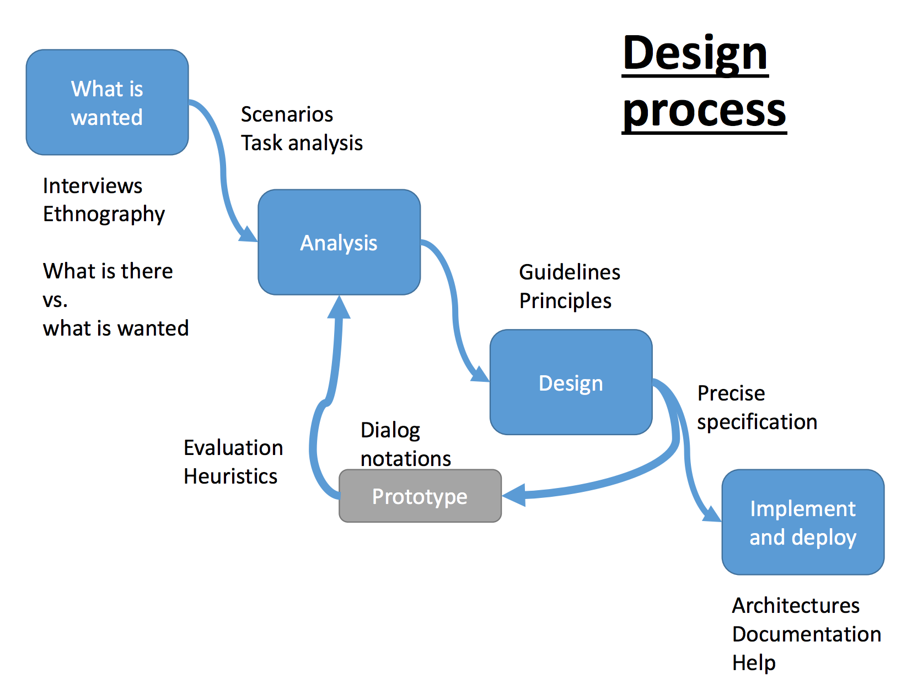

Case study: people missed population clock on Census Bureau website because it looked like an ad

# Study design

Four-step process:

* Step 1: Define what “usable” means
* Step 2: Identify your variables
* Step 3: Setup your study
* Step 4: Evaluate the outcome

Step 1: Define your usability goal

* This step is very similar to specifying tasks for a think-aloud type study
* Identify what you think your users need to be able to do using your system
* The goals need to be specific and easy to identify if they have or have not been completed
* Examples:
  + Find a stool on a shopping page and purchase it
  + Locate the nearest bus stop that the 8 bus stops at
* Bad examples:
  + Have fun using the site
  + Find a bus to go somewhere

Step 2: Identify your variables

* Dependent vs. independent
* Example, for permissions app:
  + Goal: User can identify if an app can or cannot perform an action directly tied to a permission.
  + Dependent
    - Number of permissions correctly/incorrectly read
    - Time spent reading the permission screen
  + Independent
    - Study group
    - Order of the permissions
    - Time of day
    - Type of device (laptop, mobile, PC)
    - Demographics of the participants

Step 3: Setup your study

* What do you want to be able to say after the evaluation is done?
  + X interface is better than Y interface
    - Run an A/B study
    - Randomly assign users to groups
    - Have all users complete the same tasks
  + My new interface is better than my old interface
    - Same as above
    - Or use rapid usability approach
  + Users can use interface X to accomplish Y
    - Have users accomplish a set of tasks using X
    - Measure the usability (see step 2)
  + Using my interface makes people better/smarter
    - Pre/post test – give them the same test before and after using your system
* Between vs. within subjects:
  + Between: One group of people is control, other test
  + Within: All people get both interfaces or whatever
* Scripted vs. observational
* For permissions problem:
  + A/B test between the existing and new interface
  + Between subjects
  + 10 Tasks shown in the same order to all participants
  + Dependent variables
    - Accuracy on task
  + Independent variables
    - Which interface

Step 4: Evaluate the outcome

* Can use statistical tests like: Regression, T-Test, ANOVA, Chi-squared

# News

Privacy Zuckering: You are tricked into publicly sharing more information about yourself than you really intended to.

Admiral car insurance wanting to use Facebook data to determine who’s risky. “Facebook’s policy says its data should not be used to ‘make decisions about eligibility, including whether to approve or reject an application or how much interest to charge on a loan’.”

"The Magical Number Seven, Plus or Minus Two: Some Limits on Our Capacity for Processing Information"[1] is one of the most highly cited papers in psychology.[2][3][4] It was published in 1956 by the cognitive psychologist George A. Miller of Princeton University's Department of Psychology in Psychological Review. It is often interpreted to argue that the number of objects an average human can hold in working memory is 7 ± 2. This is frequently referred to as Miller's Law.